
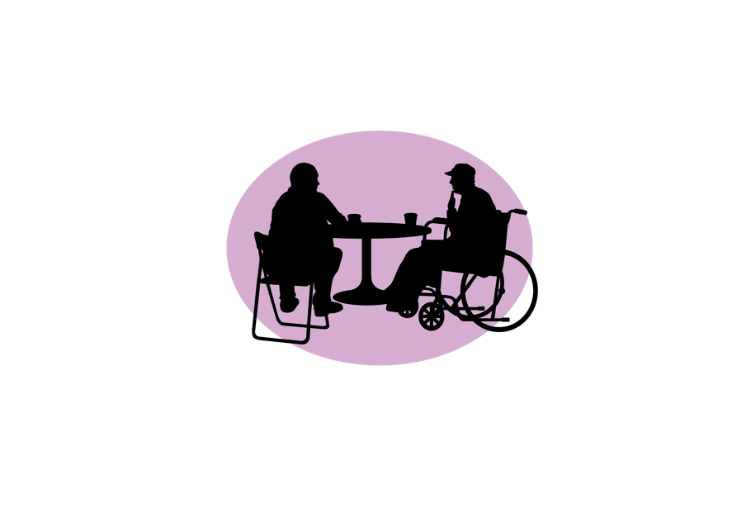

Patient and Public Involvement
and Engagement Strategy 2026
Summary
NIHR King’s Clinical Research Facility (CRF)
King’s College Hospital


A full version and an easy read version are also available.

Executive summary
This document outlines our 2026 Patient and Public Involvement and Engagement (PPIE) strategy at the King’s Clinical Research Facility (CRF).
PPIE means working with the public to shape research and sharing research with wider communities. It helps us better understand people’s needs and improve how we carry out research.
We work in partnership with NHS organisations, academic institutions, and our public members.
Our ambition is to place PPIE at the heart of our work. We will do this through four key goals: promoting our work, improving the experience of involvement, engaging young people, and evaluating our impact.
This strategy is supported by dedicated staff, clear governance structures, and ongoing evaluation to ensure we continue to learn and improve.

About this strategy
This is a summary of our Patient and Public Involvement and Engagement (PPIE) strategy for 2026. It builds on the outcomes of our 2023–2025 PPIE Strategy and has been updated based on feedback from PPIE members and CRF staff, gathered through a strategy refresh survey in summer 2025. The full version and an easy-read version are also available.

About the King’s Clinical Research Facility
The King’s Clinical Research Facility (CRF) is based at King’s College Hospital and is funded substantially by the National Institute for Health and Care Research (NIHR). We support clinical trials on a broad range of topics, including mental health and general medicine, working in partnership with South London and the Maudsley NHS Foundation Trust (SLaM) and King’s College London (KCL). The CRF includes an Experimental Medicine Facility, a Cell Therapy Unit, a Clinical Trials Facility, and an Imaging Facility.

What Is PPIE?
PPIE stands for Patient and Public Involvement and Engagement. Involvement means research is carried out “with” or “by” members of the public rather than “to”, “about” or “for them”. Engagement is the process of communicating information and knowledge about research to the public. PPIE helps us understand the needs, concerns, and priorities of those who use health and social care services, and improves how we conduct research and the outcomes achieved.
You may also see the term PPI used. This refers specifically to Patient and Public Involvement. In practice, PPI and PPIE are often used interchangeably.

Our Partners
We work alongside King’s Health Partners (KHP), King’s College Hospital (KCH), King’s College London (KCL), South London and the Maudsley (SLaM) and its Biomedical Research Centre (BRC), the NIHR, and our public members. Our PPIE group and wider public member network are key partners, working with us through a co-production approach. We aim for both to reflect the diversity of the South London population we serve.

Our Ambition, Aim, and Principles
Our ambition: to develop a culture that places PPIE at the heart of all aspects of our work.
Our aim: to raise awareness of our research, and to promote meaningful and attractive PPIE opportunities related to our research and work.
Our principles are built on the UK Standards for Public Involvement:
- Responsive: we will take ideas onboard and make changes when they are needed
- Respectful: we will listen to, and learn from, diverse opinions and voices
- Relationship-centred: we will value everyone and the unique experiences they bring to our work

Our Goals
Our four goals remain from the 2023–2025 strategy. The actions under each goal have been updated based on progress and feedback from PPIE members and CRF staff.

 | Goal 1: Promote the CRF, our research, and work to attract members of the public | Timeline
 | a) Ensure ongoing co-production of PPIE communications (website content and social media), in liaison with the CRF Communications Lead, to share information and promote engagement opportunities with a wider population of public members and researchers. | Ongoing throughout 2026
 | b) Create and display PPIE content (e.g., involvement opportunities, upcoming events, awareness days) on CRF TV screens to share opportunities and relevant CRF information. | Ongoing throughout 2026
 | c) Work closely with the Comms Lead to develop impact case studies to publicise the important contributions of the PPIE group. | Ongoing throughout 2026
 | d) Maintain a bi-annual newsletter that participants and public involvement members can sign up to for information about relevant CRF news and upcoming events. | Biannually
 | e) Identify opportunities and events to promote the work of the CRF, including patient awareness days and public engagement initiatives (e.g., Mental Health Day, Migraine, Diabetes, Clinical Trials Day). | Ongoing throughout 2026
 | f) Identify opportunities to advertise throughout the trust including to KCH, SLaM, and KCL. | Ongoing throughout 2026

 | Goal 2: Offer a first-class experience for participants and public involvement members | Timeline
 | a) Maintain a Strategy Group of public members and CRF staff to oversee the delivery of this strategy and make changes where needed. The group will meet quarterly and be co-chaired by a public member and a CRF staff member. The group will be reviewed every three years. Themed sub-groups (e.g., EDI, advanced therapies) may be established to support specific areas of work. | Ongoing throughout 2026
 | b) Introduce a yearly training needs survey for public members and CRF staff to continually improve everyone’s experience of PPIE. | By end of 2026
 | c) Implement training on PPIE for CRF staff and researchers to be co-delivered with a public member during regular Friday teaching sessions (x2 per year). All staff must attend at least one of the sessions. | By end of 2026, then biannually
 | d) Continue identifying members to join the public involvement group and maintain a secure contact database of all interested parties. This will ensure we have a wide range of stakeholders to extend the reach of our communications and involvement and engagement activities. | Ongoing throughout 2026
 | e) Survey PPI members about their interests (e.g., strategy work, research review, events, social media) and areas of expertise (e.g., cancer, rare diseases). Use this information to maintain a secure database that supports matching members to appropriate PPI opportunities. | By end of 2026, then ongoing
 | f) Develop ‘dragon’s den’ events where public members can give immediate input on researchers’ work (including ideas for recruitment, dissemination, etc.). | Ongoing throughout 2026
 | g) Communicate PPIE opportunities clearly and transparently, setting out allocation processes and expectations for members. | Ongoing throughout 2026
 | h) Improve visibility and communication of the PPIE strategy by circulating accessible versions (full, summary, and easy-read) to PPI members and CRF staff, embedding the strategy into induction processes, and working with the CRF Communications Lead to publicise it via appropriate channels. | By mid-2026
 | i) Establish a PPIE service for commercial research organisations to deliver high-quality PPI input and expand the range of meaningful PPI opportunities. | By end of 2026

 | Goal 3: Engage and educate young people and academic institutions | Timeline
 | a) Continue to work with local schools and offer work experience and/or open days for GCSE and A-level students. | Ongoing throughout 2026
 | b) Establish a programme of school outreach workshops to raise awareness of research and research careers, prioritising local schools and under-represented groups. | By end of 2026, then ongoing

 | Goal 4: Evaluate the impact of public involvement and engagement | Timeline
 | a) Implement a ‘Data at the Door’ survey for CRF visitors and research participants to capture awareness of the CRF, interest in taking part in research, and understanding of and interest in patient and public involvement. Use the findings to identify gaps in awareness and inform communications and promotional activity. | By end of 2026, then annually
 | b) Monitor and reflect on progress with specific public involvement activities and events using evaluation forms, which are co-produced with public members. | Annually
 | c) Towards the end of the strategy period, invite public members to take part in focus groups or interviews to discuss progress made against each goal and their experience of being involved in the strategy group. | By end of 2026
 | d) Use the Public Involvement in Research Impact Toolkit (PIRIT) to record the contributions public members have made and the changes to research and practice as a result. | By end of 2026

Resources and Infrastructure
The delivery of this strategy is supported by:
- Elka Giemza, CRF Manager – with overall responsibility for putting this strategy into practice
- Flora Siklosi, PPIE Lead – with responsibility for ensuring effective involvement throughout the CRF’s activities
The following key structures support the delivery of this strategy:
- Strategy Group: a group of public members and CRF staff who meet quarterly to review progress against the strategy and explore how involvement can be strengthened. See Goal 2, action a.
- Staff training: the PPIE Lead co-delivers training on PPIE with a public member during Friday teaching sessions (x2 per year). All staff are expected to attend at least one session. See Goal 2, action c.
Public members are paid up to £27.50 per hour for their time, in line with current NIHR benchmarks. Reasonable travel expenses are also reimbursed. We want to ensure that payment is not a barrier for anyone who wishes to be involved.

Governance and Evaluation

Governance
- PPIE and EDI are standing agenda items at monthly management board meetings
- 2 public members sit on the governance committee to provide feedback and report on PPIE activities. These roles rotate every three years
- 4 PPIE champions are designated among CRF research nurses and clinical research practitioners. These roles rotate every three years

Evaluation
Progress against this strategy will be reviewed through:
- Quarterly progress reviews with the Strategy Group
- Evaluation forms and ongoing feedback on PPIE activities and events
- End-of-year feedback from CRF staff, researchers, and public members
- Application of the UK Standards for Public Involvement as an evaluation tool
- Use of the PIRIT toolkit to track the impact of public involvement at project level

Contact
To find out more or to get involved with PPIE at the King’s Clinical Research Facility, please contact the PPIE Lead:
kch-tr.kingscrfppi@nhs.net, Website: https://kingscrf.nihr.ac.uk
This strategy is also available as a full document and in easy-read format.

